**WEB TECHNOLOGY PROJECT**

**Find a Roommate**

By-

Pratik Panjwani-48

Rahul Rai-52

Aditya Rathi-54

**Problem Definition**

This project on implementation will provide an aggregated environment of tenants,landlords and on a bigger scope brokers for better view and thereby transparency in the financial field of residency.

**Introduction:-**

This web portal will be a community on the internet for roommates, apartment-owners,flat-owners, etc. It will help match roommates with a compatible personality. The idea of the service is to connect people who need a roommate or have an apartment to sublet with those who need a flat. Users can browse through the community looking for people with rooms to rent or for people looking for one of those rooms. This web portal will offer various features like the ability to search for roommates filtered by age,interest or location.

**User Profiles:-**

There will be different types of registered users on the portal depending upon their needs-

a)People looking for new rooms:

These users will search for new rooms using the custom search engine provided with filters. Empty or partially filled rooms will be shown to this section of users.

b)People looking to rent their rooms:

These type of users will complete the entire profile of their residence to be put up on rent with details of size , accommodation, furnishings and rent expectation etc.

c)People looking for other roommates and already holding rooms:

These users will search for compatible roommates on the search engine and choose or notify the most appropriate one.

**Additional Services:-**

On an extended scope, there will be free users and premium users. For free users there will be advertisements popping and for premium users the ads will be disabled.

**Software Requirements:-**

1. HTML
2. CSS,CSS3
3. PHP and MySQL
4. JavaScript/ JQuery
5. AJAX.

**Application design:**

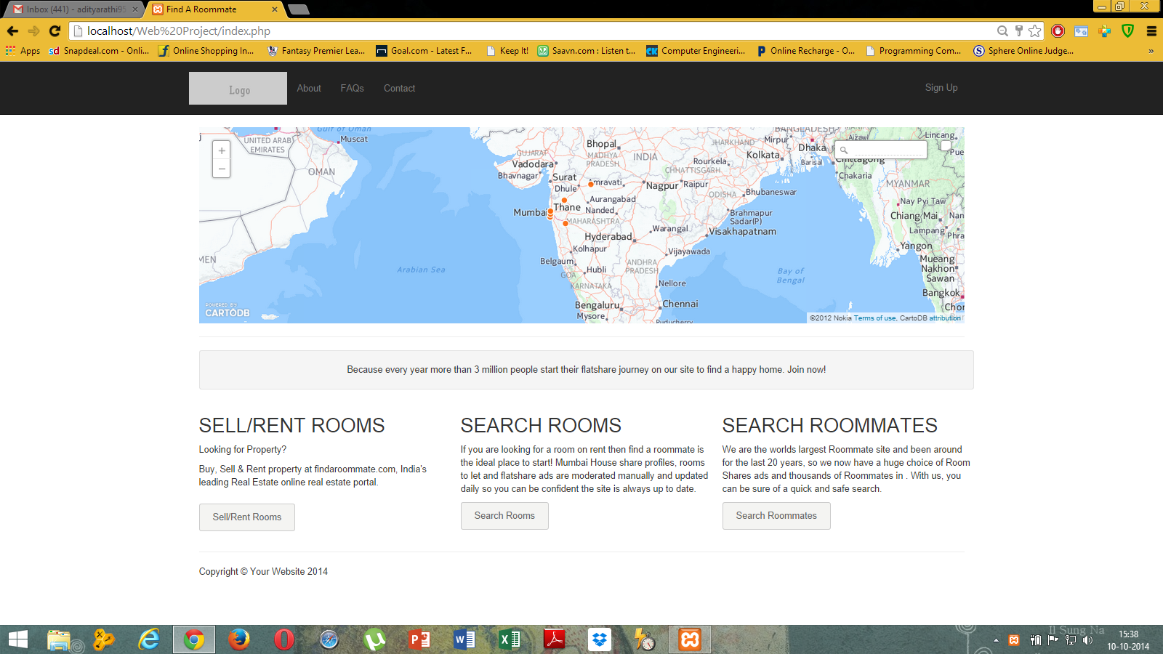

Index.php

Shows an overview of the content on the website

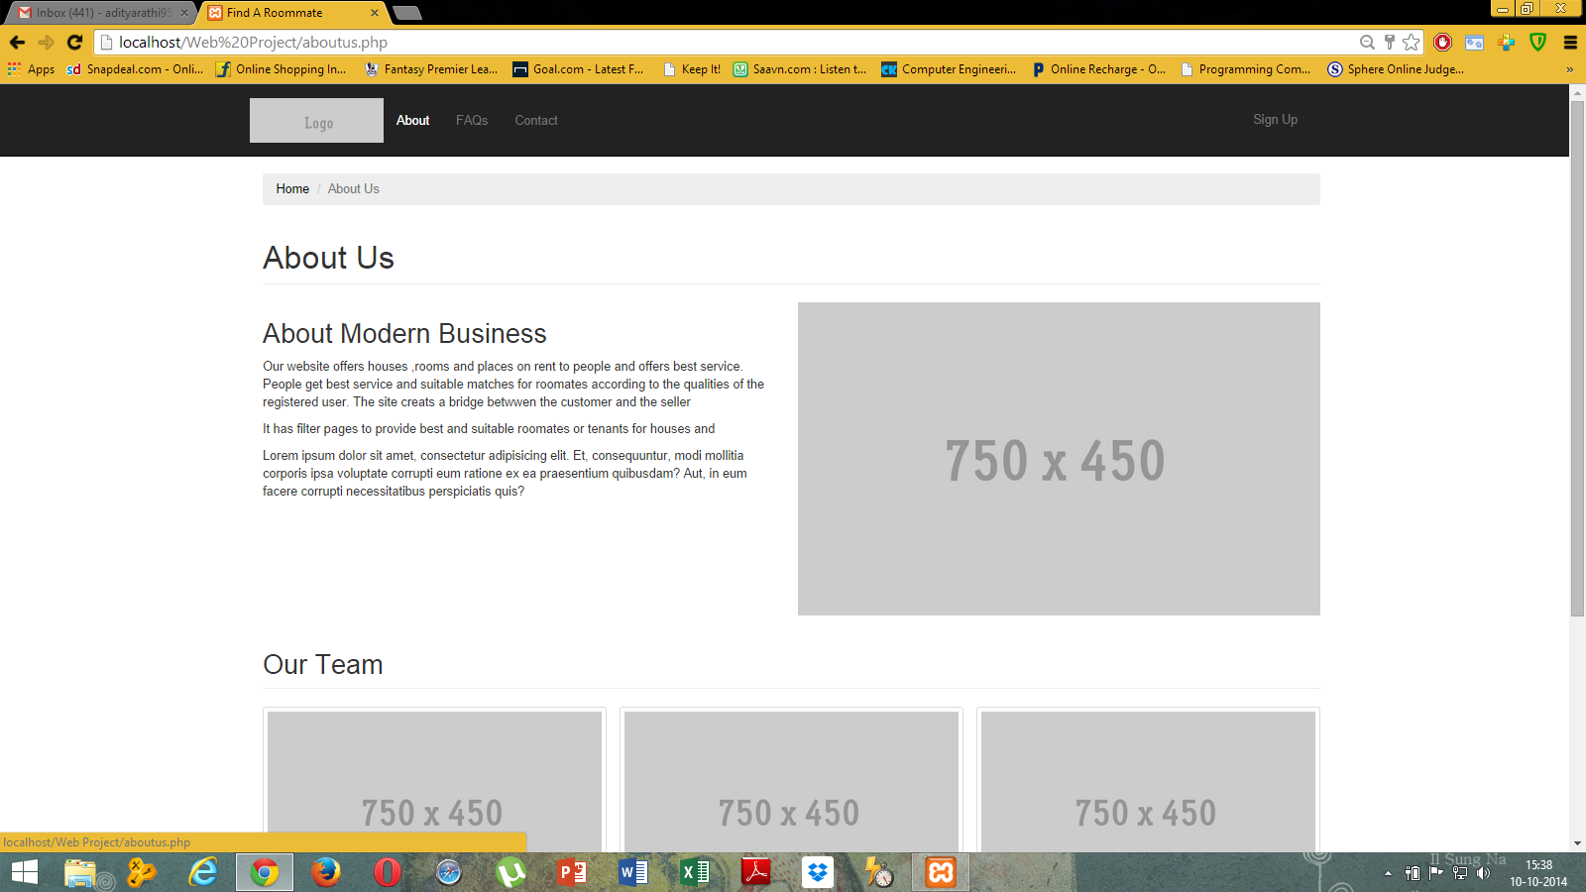

Aboutus.php

Gives details regarding developers of the website.

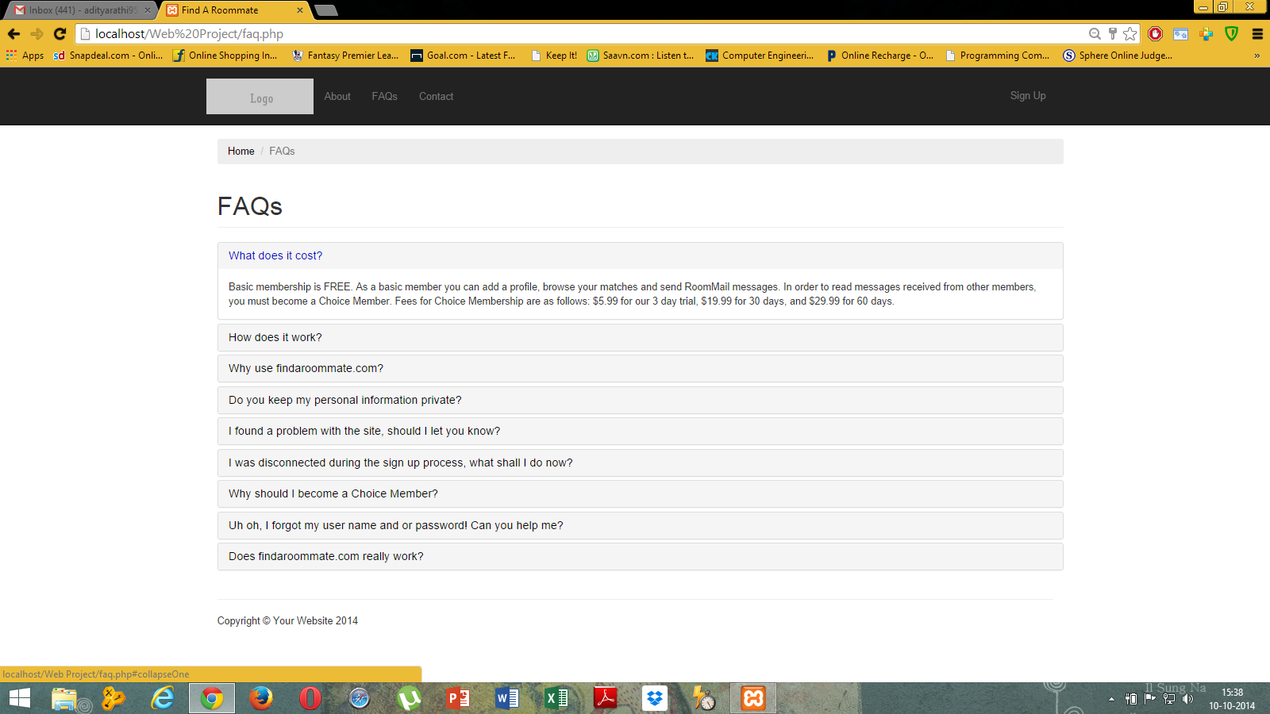

Faq.php

Displays frequently asked questions regarding content and inputs on the website.

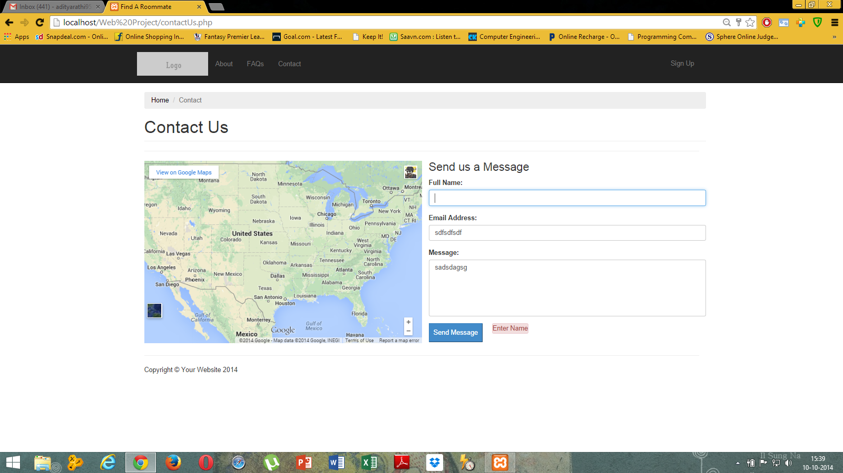

Contactus.php

Gives user the liberty to contact the developers regarding doubts in working or understanding of the website.

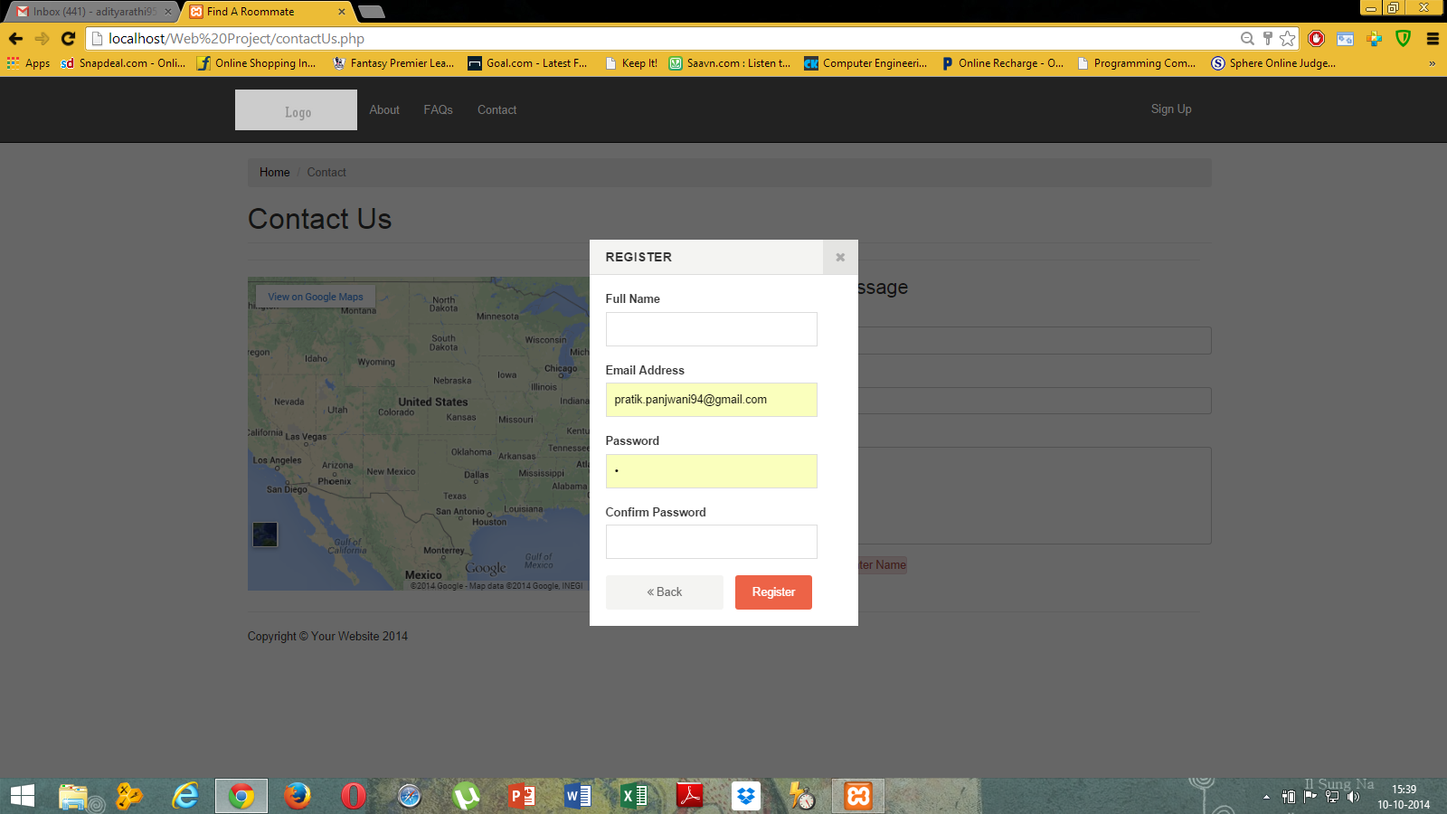

Signup Modal

For an unregistered user to register.

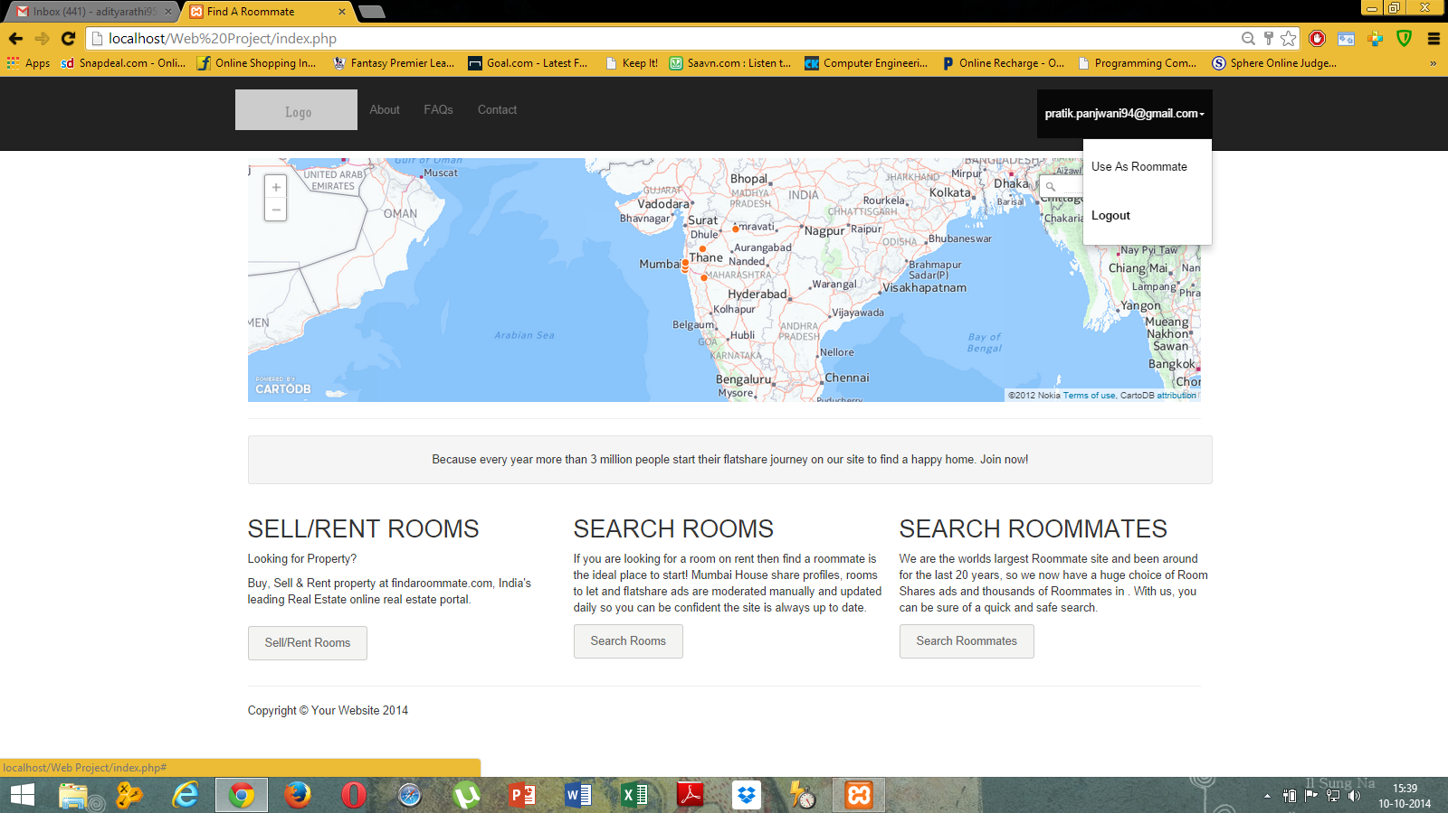

User dropdown

To use the session as a different profile or logout of the session.

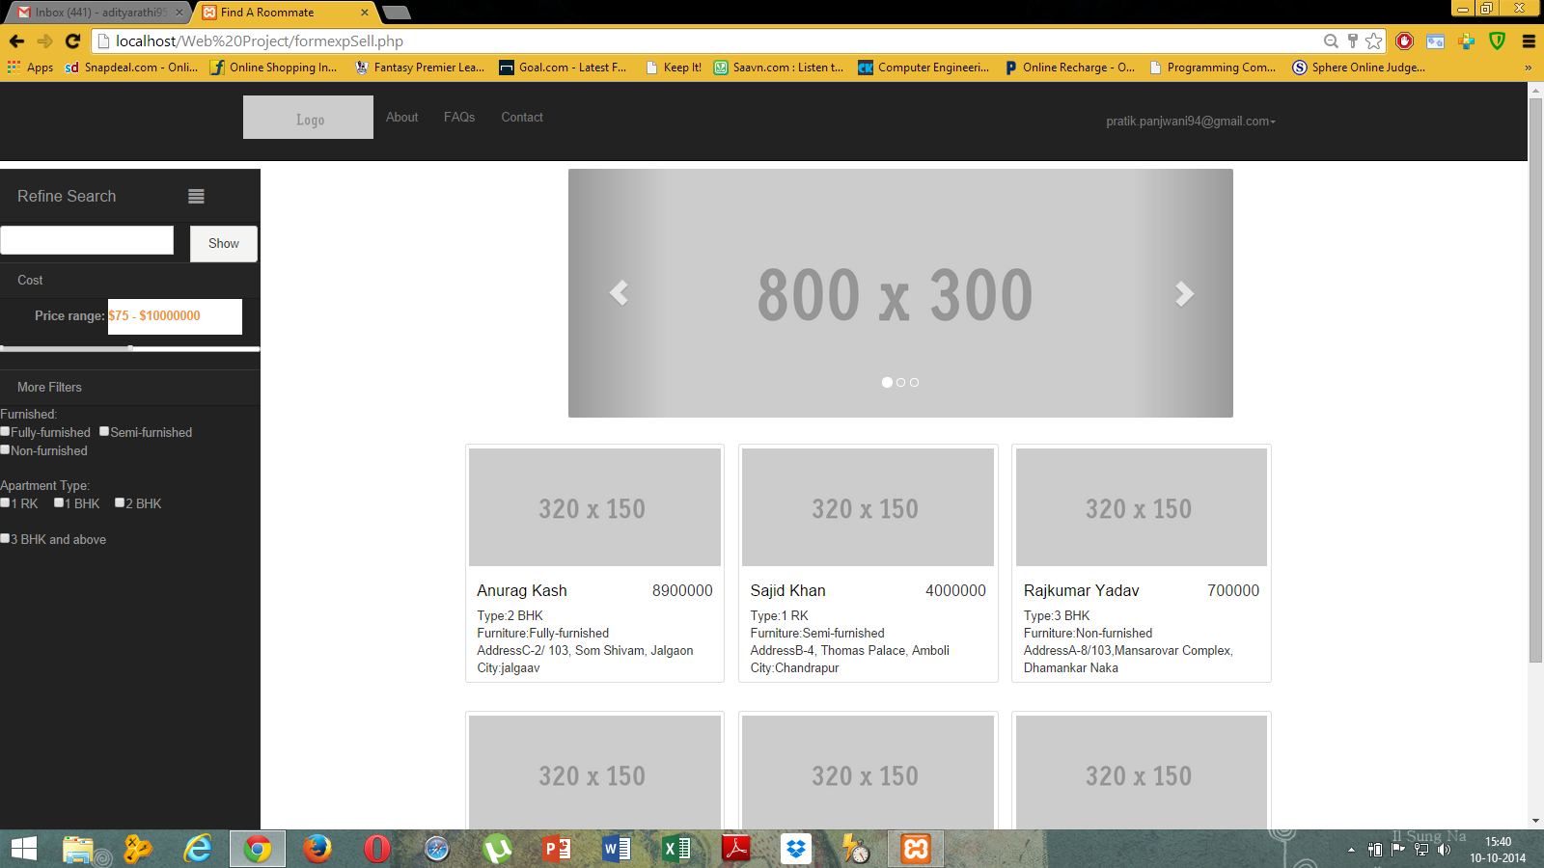

formexpSell.php

To search for different rooms according to the user’s search parameters.

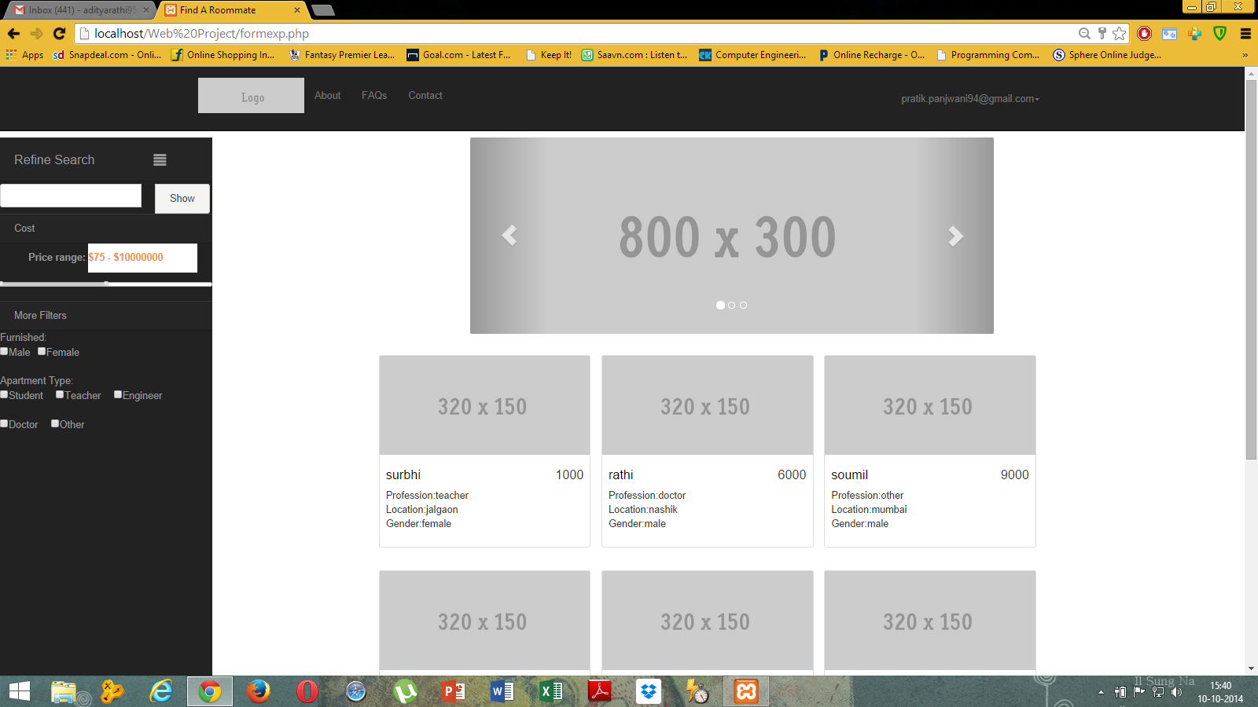

Formexp.php

Gives an option to the user to filter out results regarding roommates.

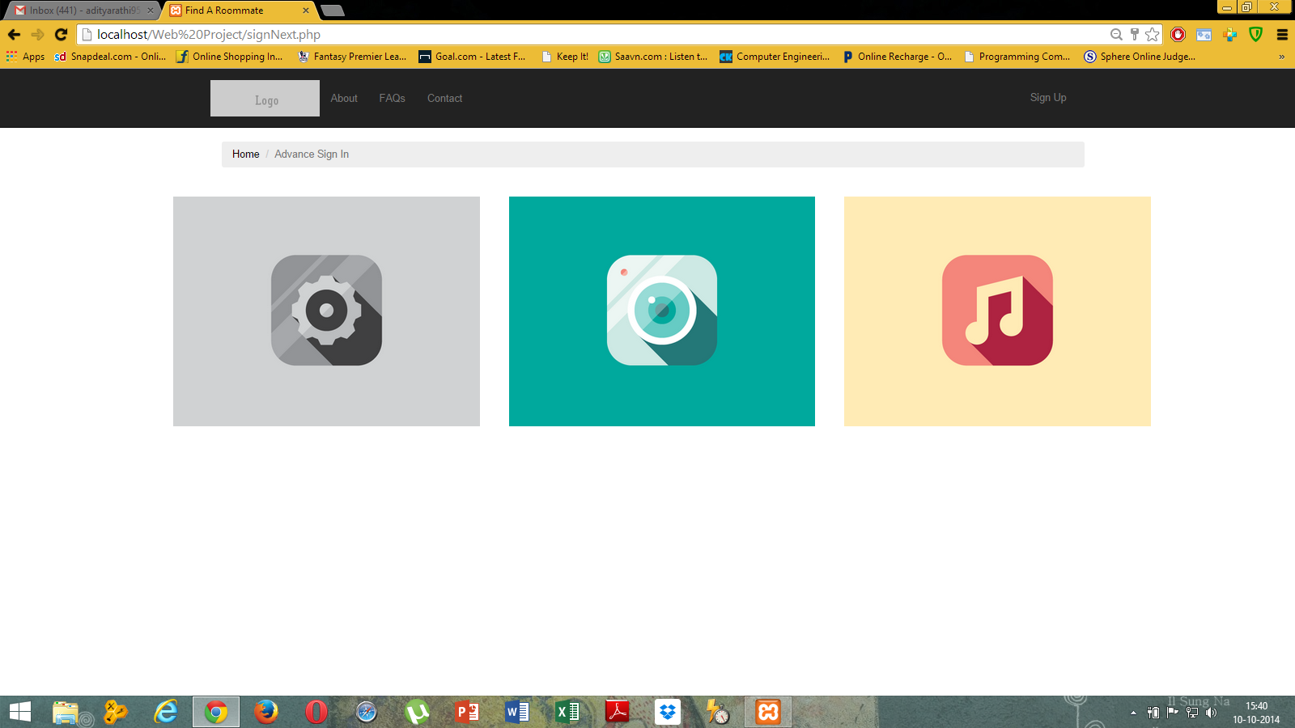

signNext.php

To register as a more detailed user on the website

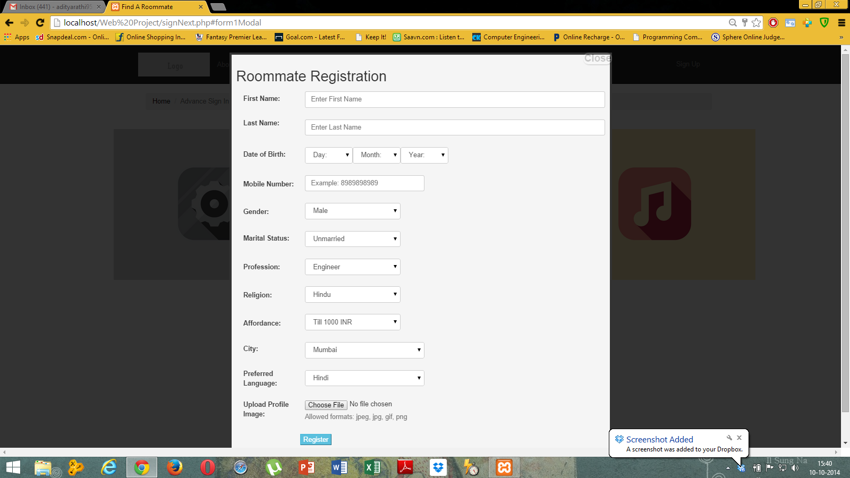

Roommate registration modal

Displays form to the user to sign up as a roommate.

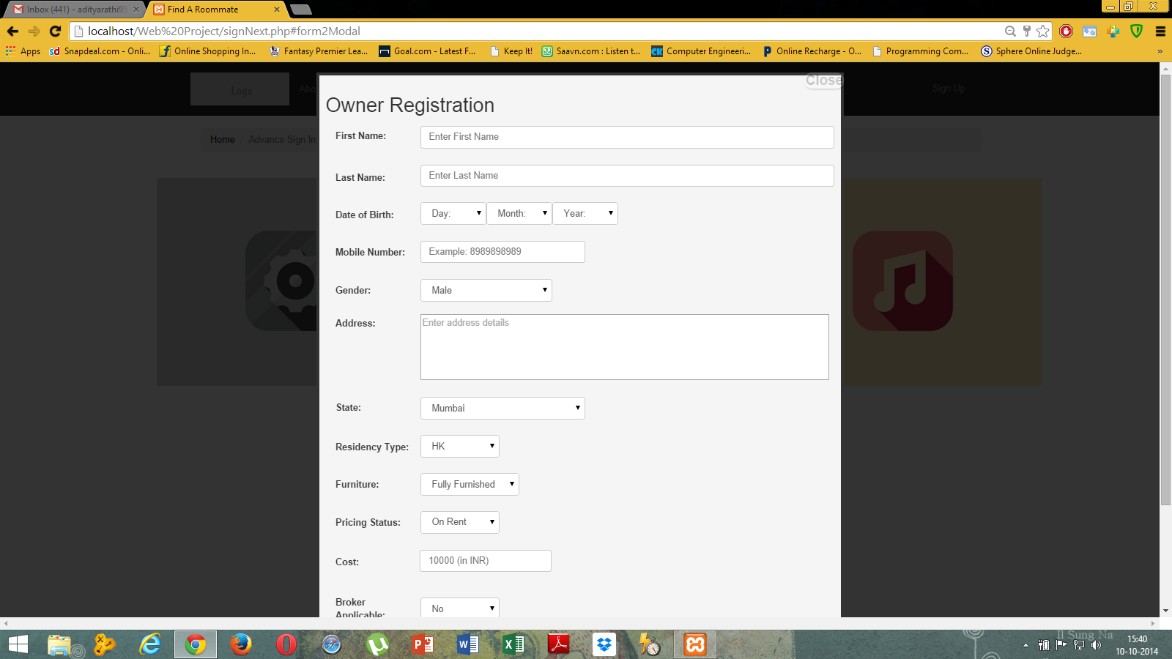

Owner Registration Modal

Displays form to the user to sign up as an owner.

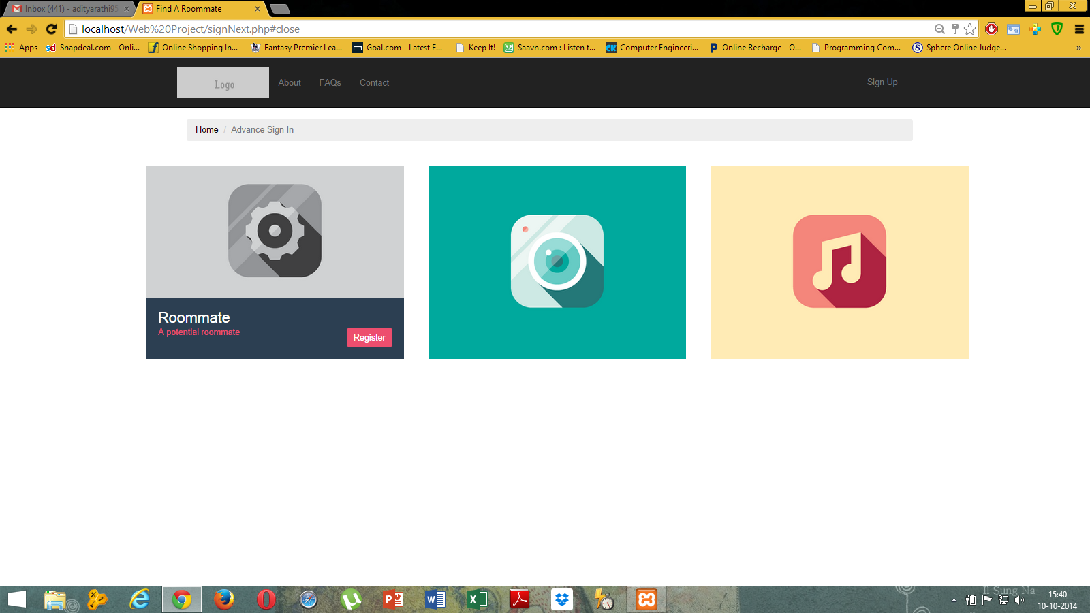

SignNext.php

Gives various links to various form modals to sign up as either roommate, owner or seller.

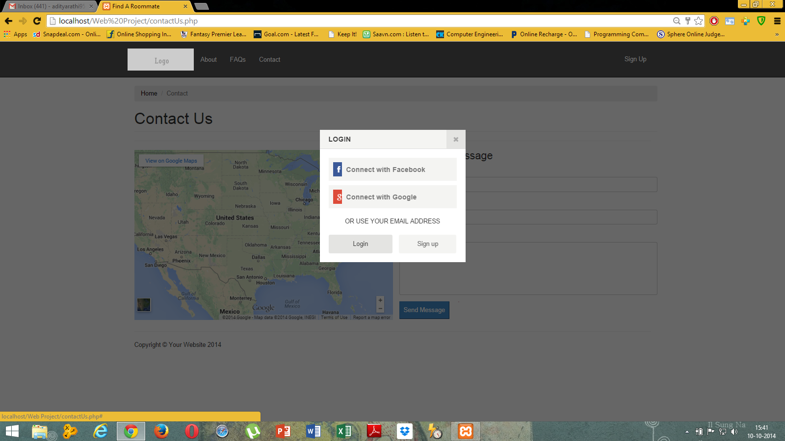

Login/Register modal

Gives an option to either login or signup on the website portal

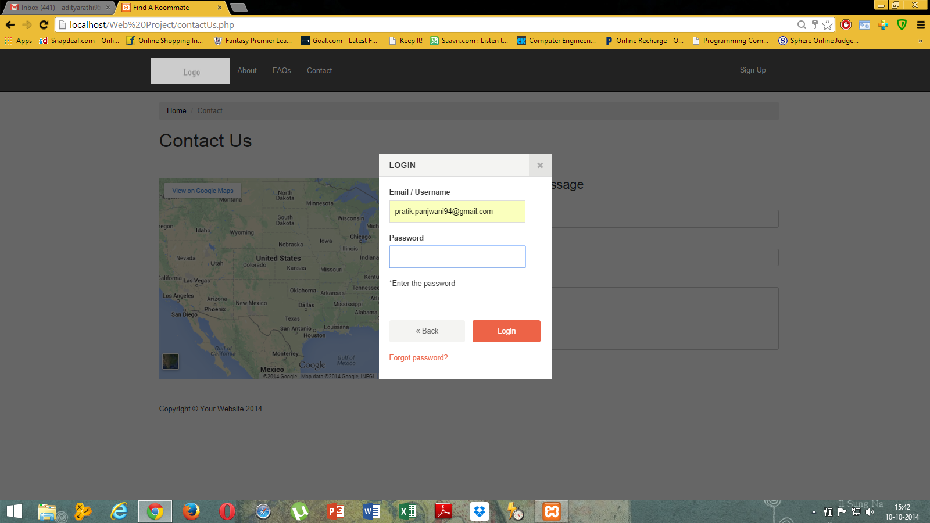

Login modal (Validation check)

Incorrect login details are not allowed.

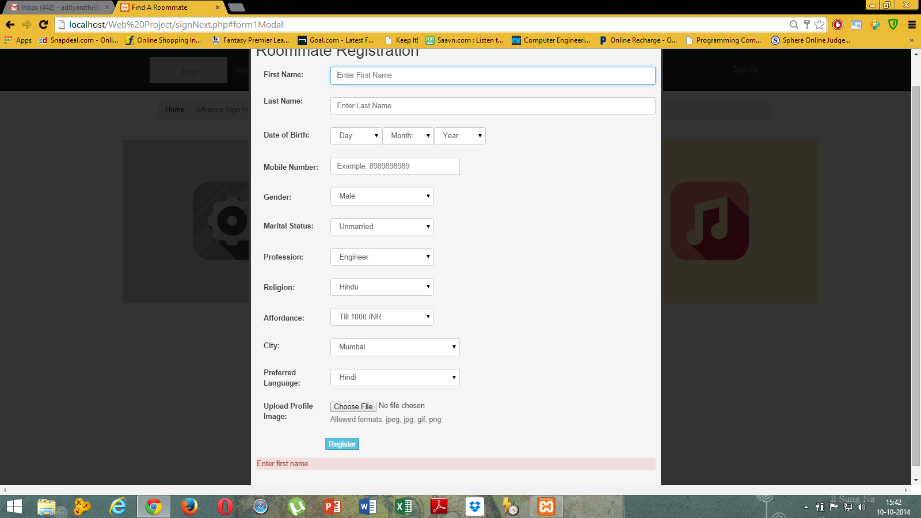

Roommate Registration (Validation check)

Incorrect details on the form are not allowed

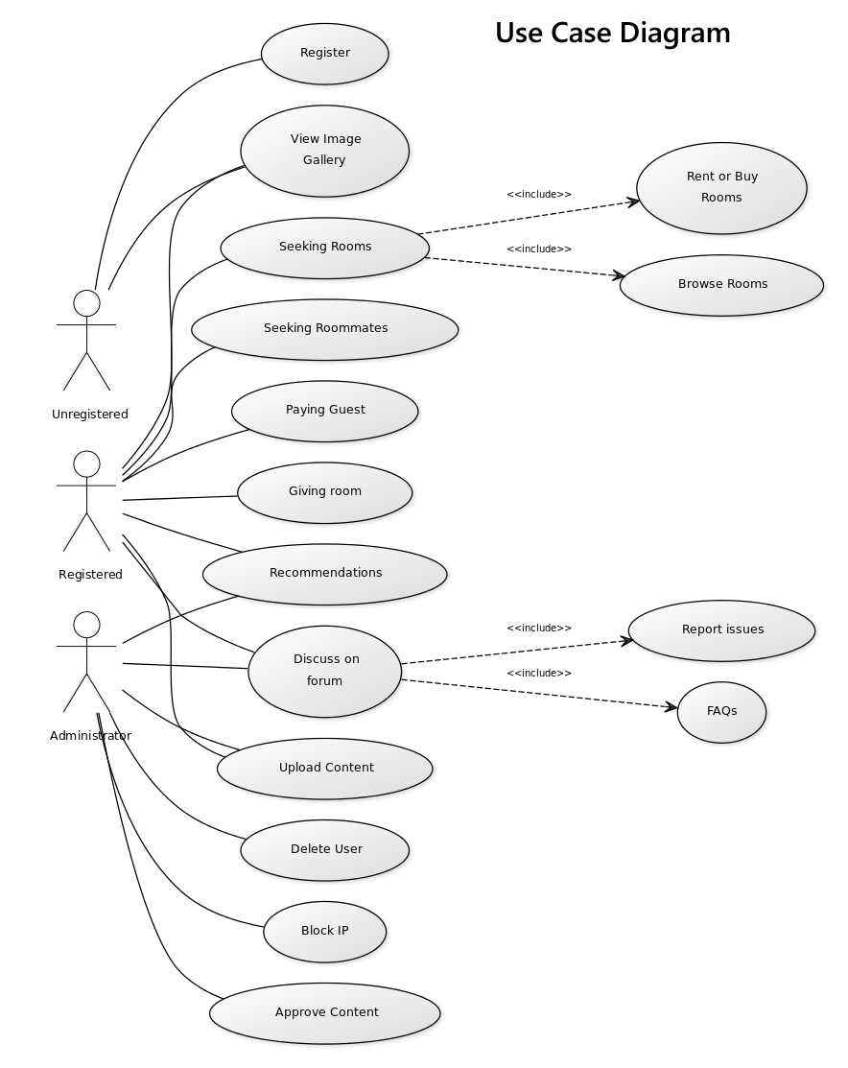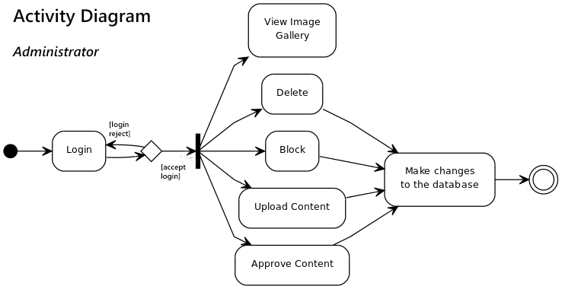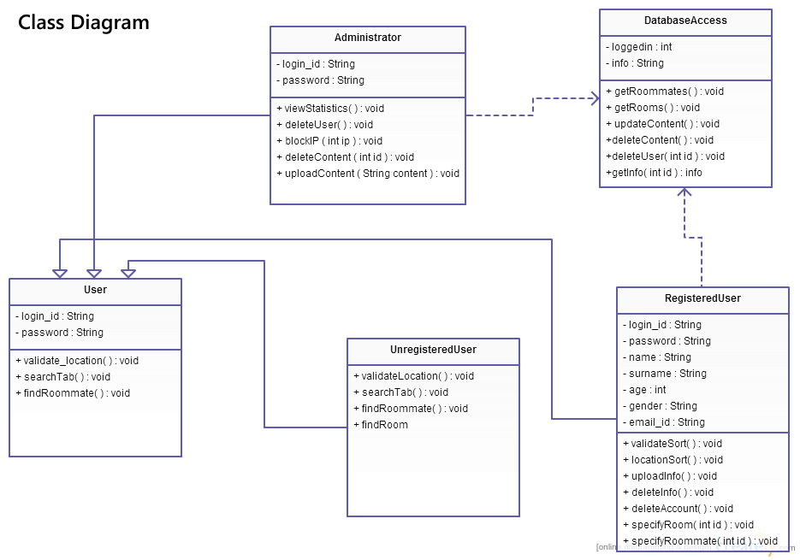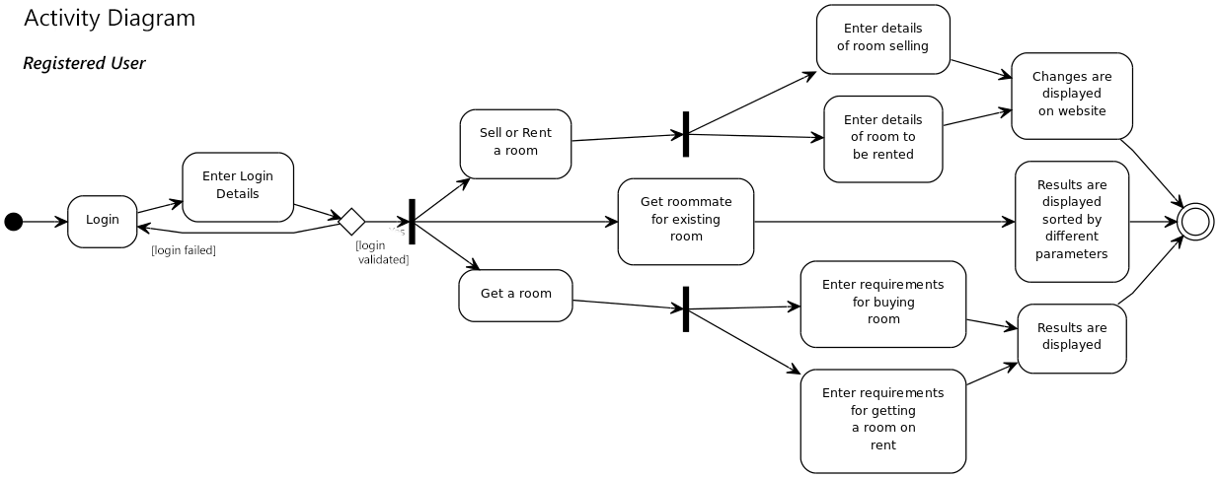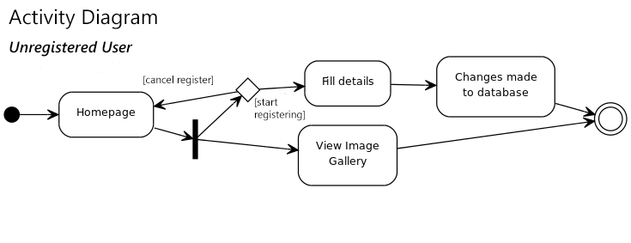

**Testing**

Web testing is the name given to software testing that focuses on web applications. Complete testing of a web-based system before going live can help address issues before the system is revealed to the public. Issues such as the security of the web application, the basic functionality of the site, its accessibility to handicapped users and fully able users, as well as readiness for expected traffic and number of users and the ability to survive a massive spike in user traffic, both of which are related to load testing.

**Unit Testing:**

Unit testing is a software development process in which the smallest testable parts of an application, called units, are individually and independently scrutinized for proper operation. Unit testing is often automated but it can also be done manually. This testing mode is a component of Extreme Programming (XP), a pragmatic method of software development that takes a meticulous approach to building a product by means of continual testing and revision.

|  |  |  |  |  |  |
| --- | --- | --- | --- | --- | --- |
| Sr. No | Test Plan | Test cases | Expected Result | Actual Result | |
| 1. | Login | Check username and password | If the user is already the customer or registered then he/she is prompted to login. If the username and password matches with those in database then there should be no errors displayed otherwise error ‘Username and password mismatch’ error is displayed. | If the user was already the customer or registered then he/she was prompted to login. When the username and password matched with those in database then there were no errors displayed otherwise error ‘Username and password mismatch’ error was displayed. | |
| 2. | Register | Validate the Inputs | The user fills the registration form . After filling the form inputs like the email id are validated. If there is some problem then error is popped up regarding input is required. | The user filled the registration form .Inputs like the email id, contact no were validated. When there was some problem then error was popped up regarding input was required. | |
| 3. | Search Room | Option to input search parameters | User’s details are checked for searching results. If the user is unregistered a default list of rooms is displayed else a filtered list is displayed. | A list of results were successfully displayed according to the user’s search parameters. Both registered and unregistered users were able to search results successfully. | |
| 4. | Search Roommates | Option to input search parameters | User’s details are checked for searching results. If the user is unregistered a default list of rooms is displayed else a filtered list is displayed. | A list of results were successfully displayed according to the user’s search parameters. Both registered and unregistered users were able to search results successfully. | |
| 5. | Sell/Buy Rooms | Option to input room details | User’s room details are validated wherever possible. The user needs to register to upload his room details for selling/buying. | The user’s room details were validated to check for illicit content and successfully uploaded on the database. | |
| 6. | Password Lookup | Validate the customers already registered | A message is prompted that the username and password mismatches. | | A message was prompted that the username and password mismatched. | |
| 7. | Edit Profile | Edit profile of user as a person | User enters additional details of himself/herself to for better search queries of themselves | The entered details are successfully validated and saved to the database upon pressing ‘Save’ button | |
| 8. | Edit Room Profile | Edit profile of user’s room | User enters additional details of the room he/she puts up to for better search queries. | The entered details are successfully validated and saved to the database upon pressing ‘Save’ button | |
| 9. | Signup as Roommate | Filling roommate profile form | User enter details as a roommate. The details are validated for illicit or irrational data and if true the user is accepted as a roommate. | User’s entered details are validated and the user is accepted as a roommate | |
| 10. | Signup as Owner | Filling owner profile form | User enter details as an owner. The details are validated for illicit or irrational data and if true the user is accepted as an owner. | User’s entered details are validated and the user is accepted as a roommate | |
| 11. | Contact developers | Filling message form | User enters personal details and message. The details are validated and if true the message is sent by mail. | The entered message is sent upon successful validation of user’s details. | |
| 12. | FAQs | Selection of frequently asked questions | Toggling of questions and answers upon user’s selection | The answer corresponding to the question selected is toggled successfully. | |
| 13. | About the site | Alignment of different divs | The different components and inclusion of new developers (their space) is checked by user for personal contact | The different divs are aligned according to the developers expectations. | |

**Integration Testing:**

**Integration testing** is the phase in software testing in which individual software modules are combined and tested as a group. It occurs after unit testing and before validation testing. Integration testing takes as its input modules that have been unit tested, groups them in larger aggregates, applies tests defined in an integration test plan to those aggregates, and delivers as its output the integrated system ready for system testing.

|  |  |  |  |  |
| --- | --- | --- | --- | --- |
| Sr. No | Test Plan | Test cases | Expected Result | Actual Result |
| 1. | Selection of Room | Enter selection criteria | Different Rooms satisfying the entered information should be displayed on the page | Room profiles were displayed on the page on entering valid information, incase no room satisfies the conditions “No match found” message is displayed |
| 2. | Selection of Roommate | Enter Selection criteria | Different Roommates satisfying the entered information should be displayed on the page | Room profiles were displayed the page on entering valid information, incase no room satisfies the conditions “No match found” message is displayed |
| 4. | To check the working of Login Logout box on Header bar | All pages of the website | The Login should change to Logout on successful Login and Login with errors should be displayed | Worked properly on all the pages |
| 5. | User Registration | As a potential roommate  As Potential tenant  As potential buyer | On completing the signup process the user is redirected to the forms page; Three forms are displayed on this page | If the users fills valid data into the form, the user is redirected to home page and “successfully registered” message is displayed else invalid data message is displayed and data fields are reset |

**Link Testing:**

Link test is to test a group of unit to ensure that the unit operate correctly in combination. It is normally performed after the individual unit have been tested in isolation and prior to the integration testing that is performed for the complete system.

|  |  |  |  |  |
| --- | --- | --- | --- | --- |
| Sr. No | Test Plan | Test cases | Expected Result | Actual Result |
| 1. | Confirm Room | Click on the room notify button | If any room is selected, user is redirected to the room profile page and upon pressing ‘Notify’ button the owner is notified | If the room was selected, user was successfully redirected to its profile page and upon clicking ‘Notify’ button, the owner was notified. |
| 2. | Confirm Roommate | Click on the roommate notify button | If any roommate is selected, user is redirected to the person’s profile page and upon pressing ‘Notify’ button the person is notified | If any roommate was selected, user was successfully redirected to his/her profile page and upon clicking ‘Notify’ button, the owner was notified. |
| 3. | Register New User | Click on the Register link in the Login Pop up box | The user is popped up with the Registration Form page. | The user was popped with the Registration Form page. |

**System Testing:**

System testing of software or hardware is testing conducted on a complete, integrated system to evaluate the system's compliance with its specified requirements. System testing falls within the scope of black box testing, and as such, should require no knowledge of the inner design of the code or logic.

As a rule, system testing takes, as its input, all of the "integrated" software components that have passed integration testing and also the software system itself integrated with any applicable hardware system(s).

|  |  |  |  |  |
| --- | --- | --- | --- | --- |
| Sr. No | Test Plan | Test cases | Expected Result | Actual Result |
| 1. | Login | Login with valid credentials. | All pages will reflect the logged in user with the word ’Logout’. | All pages reflected the logged in user with the word ’Logout’ |
| 2. | Registration | Register the new user and update database. | After the user is registered, he/she will be redirected to the homepage. He can now login with the previously entered details. | After the user was registered, he/she was redirected to the homepage. He could now login with the previously entered details. |
| 3. | Updating of database. | Deals with the adding or editing of the user profile. | If any user is added or if he edits his profile, then the changes appear in the database and the same will be reflected on the filter page. | If any user was added or if he edited his profile, then the changes appeared in the database and the same was reflected on the filter page. |

**Browser Testing:**

Browser Testing is a process to test web applications across multiple browsers. Browser testing involves checking compatibility of your application across multiple web browsers and ensures that your web application works correctly across different web browsers. Browser testing involves testing both the client side and server side behavior of your Web application when it is accessed using different Web Browsers.

|  |  |  |  |  |
| --- | --- | --- | --- | --- |
| Sr. No | Test Plan | Test cases | Expected Result | Actual Result |
| 1. | Google Chrome | Entire website | Should display and work properly | The website worked properly |
| 2. | Mozilla FireFox | Entire website | Should display and work properly | The website worked properly |
| 3. | Opera | Entire website | Should display and work properly | The website worked properly |
| 4. | Safari | Entire website | Should display and work properly | The website worked properly |
| 5. | Internet Explorer | Entire website | Should display and work properly | Alignment problems in forms |